

**Placement Empowerment Program**

***Cloud Computing and DevOps Centre***

Department : IT

**Name: Sanjay Raj S**

***Host a Static Website on a Cloud***

***VMInstall Apache/Nginx on your***

***cloud VM and host a simple HTML***

***website.***

***Introduction***

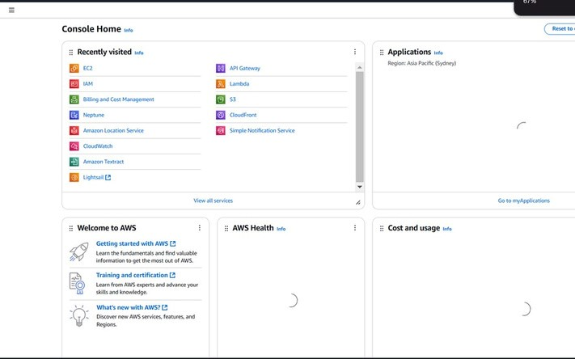***Hosting a static website on a cloud virtual machine (VM) provides a scalable and costeffective solution for deploying simple web pages. AWS offers flexible options for setting up a web server using Apache or Nginx on an EC2 instance. This guide provides step-by-step instructions on configuring an EC2 instance to host a static HTML website using either Apache or Nginx.***

***Steps to Host a Static Website in AWS***

***1. Launch an EC2 Instance***

***Log in to AWS Console:***

***Create a New EC2 Instance:***

***Click on Launch Instance.***

***Choose an Amazon Machine Image (AMI) (e.g., Amazon Linux, Ubuntu).***

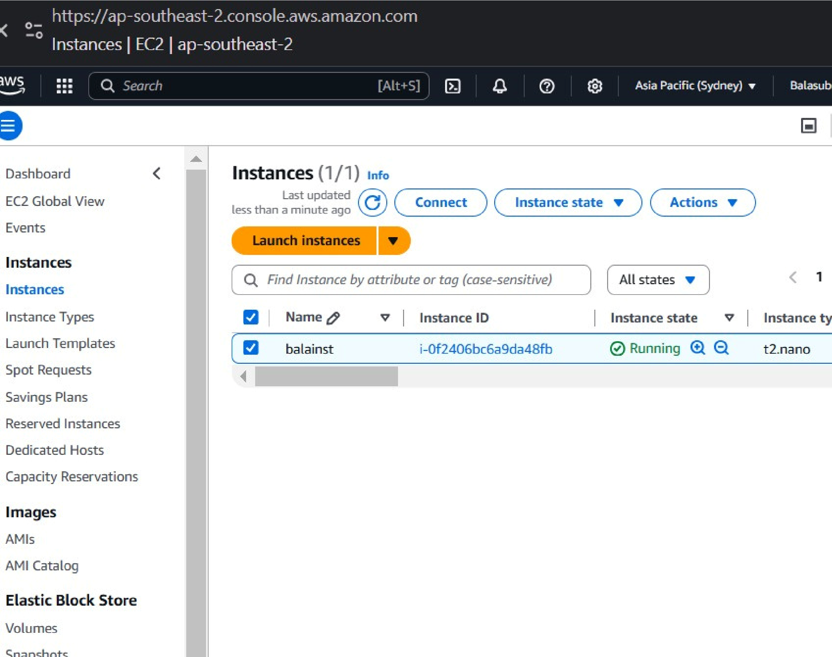 ***Select an appropriate instance type (e.g., t2.micro for free tier users).***

***Configure instance details and enable HTTP/HTTPS traffic under Security Group settings.***

***Launch the instance and download the key pair for SSH access.***

***2. Connect to the Windows Instance and Install Apache Connect to the EC2 Windows Instance:***

***Open Remote Desktop Connection (RDP) on your local machine.***

***Use the downloaded key pair to retrieve the Administrator password from the EC2 console.***

***Enter the public IP of your instance and login with Administrator credentials.***

***Install Apache Web Server:***

***Download the latest Apache HTTP Server for Windows from the Apache Lounge.***

***Extract the Apache files to C:\Apache24 (or your preferred location).***

***Open Command Prompt as Administrator and navigate to the Apache bin directory:***

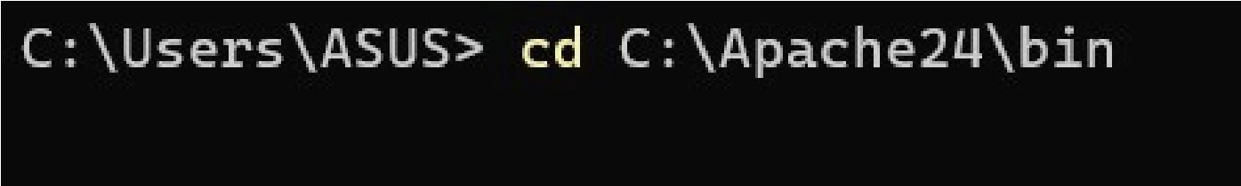





***3. Deploy a Static Website***

***Navigate to Apache Web Directory:***

***Open File Explorer and go to C:\Apache24\htdocs.***

***Upload HTML Files:***

***Create an index.html file inside C:\Apache24\htdocs and add the following content:***

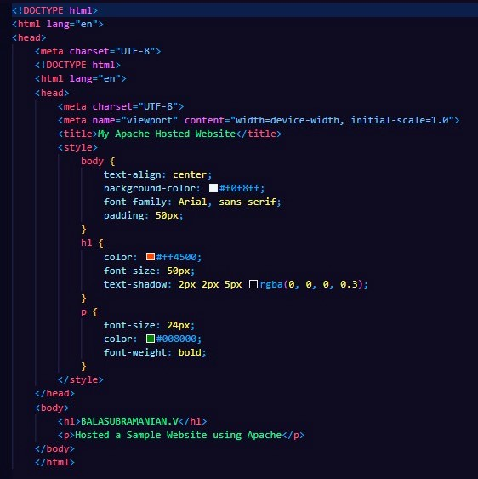

***Configure Apache to Serve Your Website: Open C:\Apache24\conf\httpd.conf using a text editor.***

***Locate the DocumentRoot directive and ensure it points to C:\Apache24\htdocs.***

***Restart Apache using:***



***4. Configure Security Group and Test Website Modify Security Group: Allow inbound HTTP (port 80) and HTTPS (port 443) traffic to access the website. Test Your Website: Open a web browser and enter your EC2 instance’s public IP address.***

***If configured correctly, your static website should load successfully.***

***Conclusion: Hosting a static website on an AWS EC2 Windows instance using Apache is a straightforward process. By following these steps, you can deploy a scalable web server in minutes. Regularly your server update to andensure secureoptimal performance and security.***